

Department of Information Technology

Bharati Vidyapeeth College of Engineering, Navi Mumbai

Academic Year 2019-2020

Mini Project Report

On

**Inventory Management System**

Submitted in partial fulfillment of the requirements of the degree of

Bachelor of Engineering

By

Ojas Daware[05]

Deep Debnath[06]

Supervisor

Prof. S. M. Satre (B-I & B-II)



Bharati Vidyapeeth College of Engineering, Navi Mumbai

Department of Information Technology

Academic Year 2019-2020

**CERTIFICATE**

This is to certify that,

Ojas Daware[05]

Deep Debnath[06]

Class- SEIT Semester-III have completed the Mini Project “Inventory Management System” Satisfactorily in the Department of Information Technology of as prescribed by the Mumbai University in the academic year 2019-2020.

Prof. S. M. Satre (B-I & B-II)

Mini Project Guide

ABSTRACT

Inventory can be defined in several ways as follows as given below:

Inventory is the stock of physical items such as materials, components, work-in-progress, finished goods, etc., held at a specific location at a specific time.

Inventory is a list of names, quantities and/or monitory values of all or any group of items. Provides protection against fluctuations in demand and supply by monitoring the trends in demand and supply. Helps to make effective utilization of working capital by avoiding its blockage in excess inventory.

In these Project we have implemented this System using java which is Platform independent. The objective of the project is to make it much more interesting by introducing the GUI(Graphical user Interface) . The project is made more user friendly so that it can be used by anybody in any field.

The project has JDBC Connection which helps in storing the data securely and retrieve that data to show the recently accessed inventory thus making it easier to be known to others.

Keywords = JDBC, GUI

**Contents**

|  |  |  |
| --- | --- | --- |
| CHAPTER NO | TITLE | PAGE NO |
| 1. | Introduction  1.1 Definition  1.2 Features  1.3 Objectives | 05  06  06 |
| 2. | Review of Literature | 07 |
| 3.    4.  5. | System Study  3.1 Existing System  3.2 Proposed System  3.3 System Requirements  Design Specification and Implementation  4.1 Input Design  4.2 Output Design  4.3 System Architecture  JDBC Connection | 09  10  10  11  12  17  18 |
| 6. | Limitations and Future Features  Conclusion | 19  20 |
|  | References | 21 |

**CHAPTER 1: INTRODUCTION**

1.1 Definition

Inventory can be defined in several ways as follows as given below:

• Inventory is the stock of physical items such as materials, components, work-in-progress, finished goods, etc., held at a specific location at a specific time.

• Inventory is the merchandise that is purchased and/or produced and stored for eventual sale.

• Inventory is a list of what you have. In company accounts, inventory usually refers to the value of stocks, as distinct from fixed assets. An inventory would include items which are held for sale in the ordinary course of business or which are in the process of production for the purpose of sale, or which are to be used in the production of goods or services which will be for sale. • Inventory is a list of names, quantities and/or monitory values of all or any group of items.

• Any quantifiable item that you can handle, buy, sell, store, consume, produce, or track can be considered inventory. This covers everything from office and maintenance supplies, to raw material used for manufacturing, to semi-finished and finished goods, to fuel used to power equipment used in the business.

1.2 Features

This Project is the replica of an Inventory of a company with some changes and the features of the project are:

1) GUI Interface

2) Multiple values can be stored and displayed

3) Database Connectivity

4) Accurate recording of daily sales

1.3 Objectives

We made this system so that we could give our best in all possible ways and show what we learned. The Objectives of this Project are :

1) To give GUI Interface to the traditional Inventory system

2) To make it user friendly.

3) To provide an easy Interface

4) Management time is saved

5) Work connected with the purchases is systematized

**CHAPTER 2: LITERATURE REVIEW**

Application of inventory control or stock management in our selected domain – A Super market.

Inventory management or inventory control is a very useful technique for managing the stocks and sales records of a Super-market which is our selected domain of implementation for the software. The super-market stores and sales various products which includes packed foodstuffs and drinks, milk products, glossary, decorative items, cosmetics and many other products of day to day use. It also stores some costly items like wrist watches, small electronic goods, artificial jewelry etc. Also there are some household goods like washing powders, cleaning equipments, gaskets etc. Managing all these products, sufficient stocks, sales records, also analyzing sales and reordering from time to time is a difficult job. To do it more effectively and correctly a better inventory control or stock management is required. This is provided by our software ensuring an efficient inventory control and rigorous sales analysis facility. Our software helps to manage the daily sales records and assist in billing process as well. It also includes reordering level and reordering quantity and gives appropriate alerts, thus maintaining a safe stock. The software also provides authorized users to perform sales analysis of various products. By providing this facility, our software will prove to be extremely useful to adjust the purchase and sales strategies leading to an increase in profit.

**CHAPTER 3: SYSTEM STUDY**

3.1 System Requirements

Hardware Requirements

1) Window xp or above

2) Disk space 124 MB for

Software requirement

1) Java SE 8 version above

2) MySQL Connector driver

3) MySQL Database

**CHAPTER 4: DESIGN SPECIFIACTION AND IMPLEMENTATION**

4.1 Input Design

The system initially starts with the login page where you enter your username and password (fig 1) .

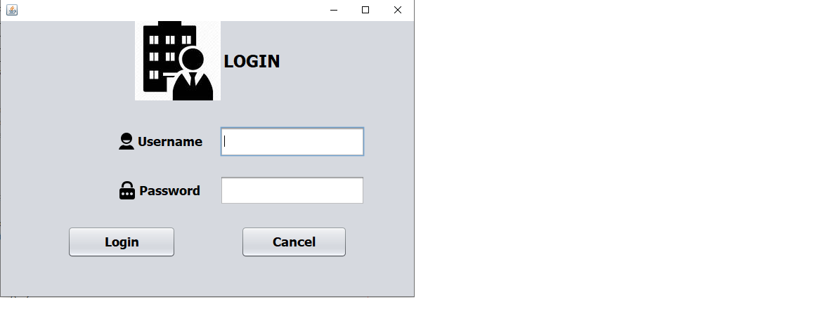

Fig(1)

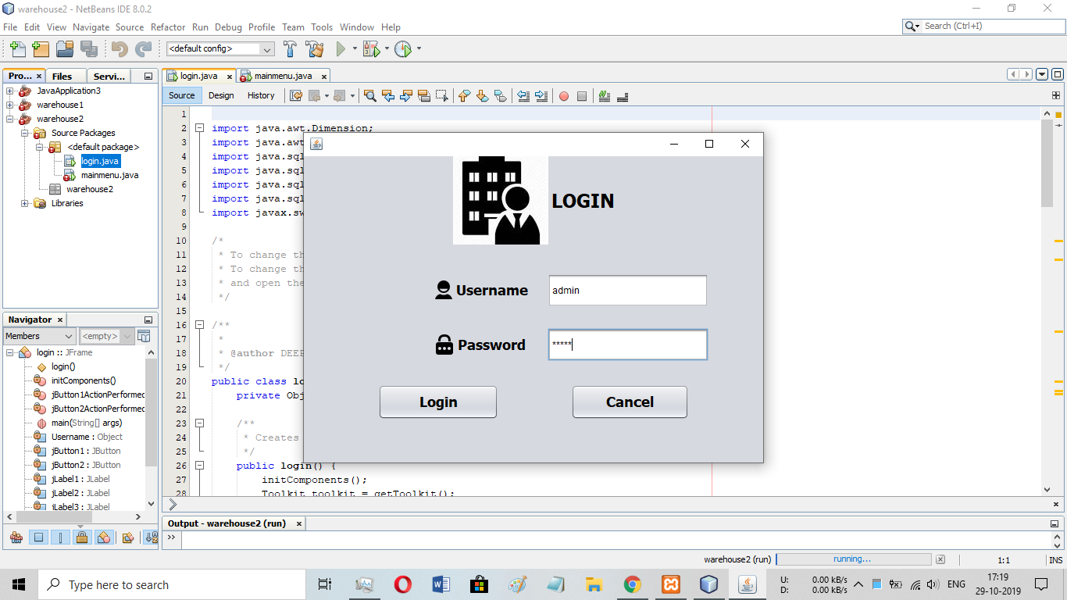

Fig (2)

4.2 Output Design

According to the given input by the user java frame will be designed and will be displayed( Fig 3). The frame will display the Sr no. , Model , Item and Quantity

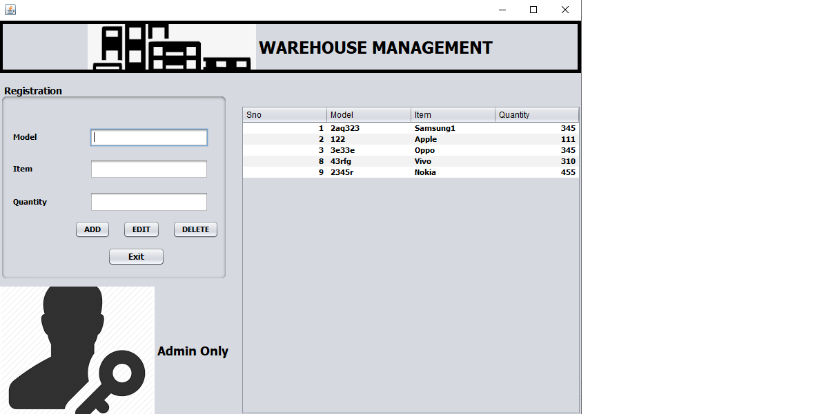

Fig (3)

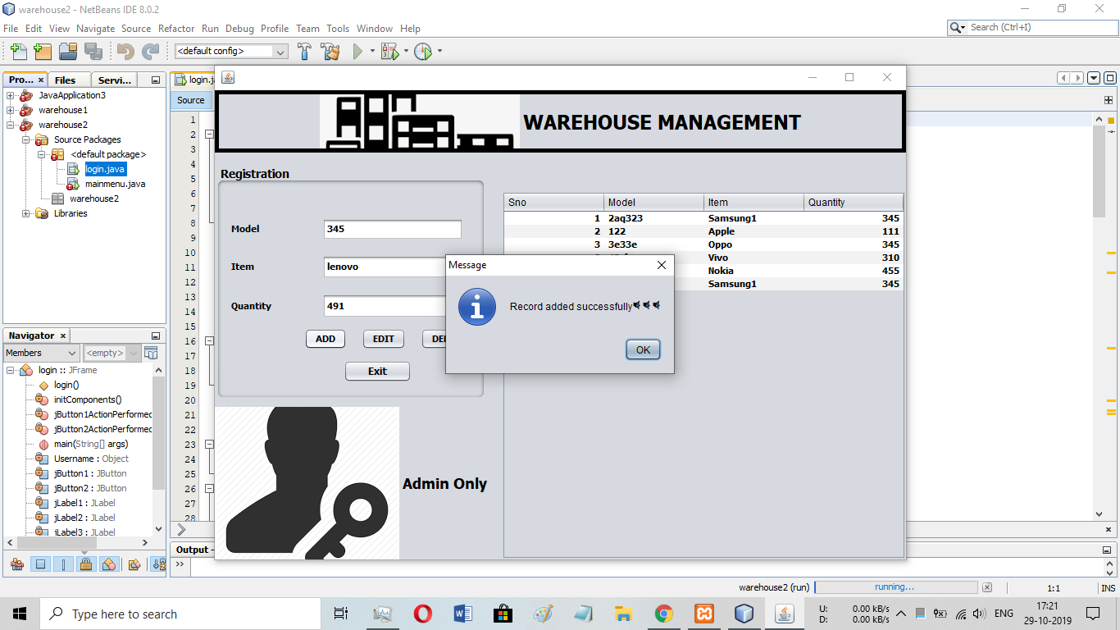

Fig (4)

Buttons

There are 4 Buttons present in this system

1) Add

2) Edit

3) Delete

4) Exit

4.3 System Architecture

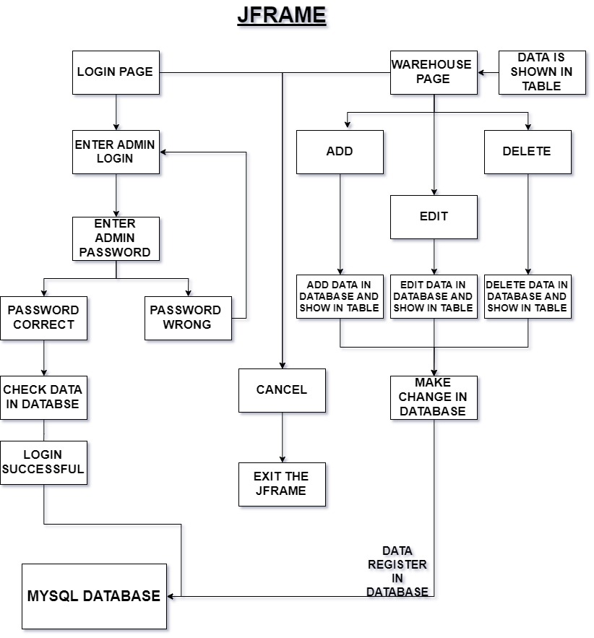

**CHAPTER 5: JDBC CONNECTION**

Java Database Connectivity (JDBC) is an application programming interface (API) for the programming language Java, which defines how a client may access a database. It is a Java-based data access technology used for Java database connectivity. It is part of the Java Standard Edition platform, from Oracle Corporation. It provides methods to query and update data in a database, and is oriented towards relational databases

XAMPP is a software distribution which provides the Apache web server, MySQL database (actually MariaDB), Php and Perl (as command-line executables and Apache modules) all in one package. It is available for Windows, MAC and Linux systems. No configuration is necessary to integrate Php with MySQL. The database of the system was made using phpMydmin.

This database saves the data after user logs in. Here in the fig shows the table present in our system database which stores the Sr no., Item and quantity of the item. This data is further used to retrieve the model of a specific item.

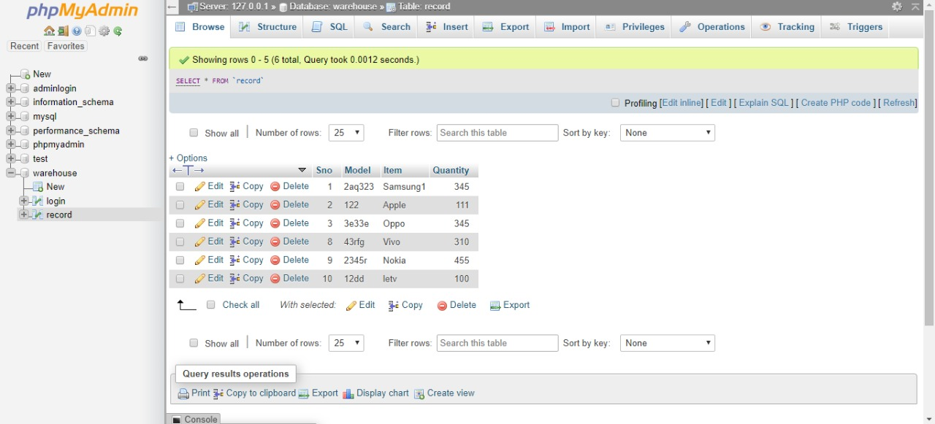

Fig

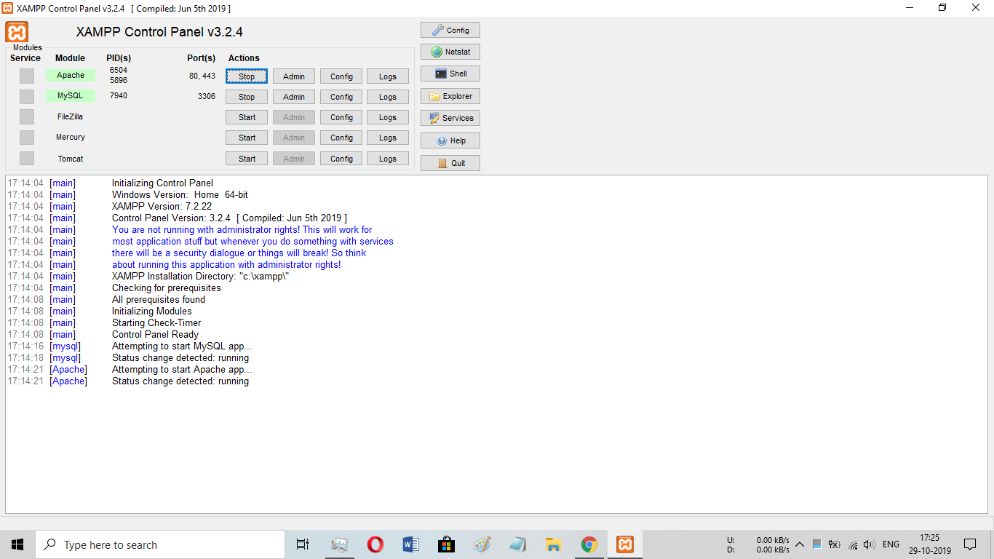

Fig

**CHAPTER 6: LIMITATION AND FUTURE FEATURES**

6.1 Limitations

1) The system does not have any graphical animations.

2) It only provides some specific parameters.

3) The system is implemented using single thread.

4) Deleted data is lost forever.

6.2 Future Features

1) Graphical animation can be introduced in the system to give a better idea of the model and item stored.

2) The Number of Parameter’s in the system can be increased.

3) The system can be implemented using multithreading to increase the speed of system

4) The service of JDBC connection can be extended to save the unfinished system data and load it afterward.

**CONCLUSION**

The primary objective of the project was to see how java, an object based oriented language can be used to make an simple inventory management system. While making these project we were able to learn the concept of GUI in java which made system attractive and interesting. Database connectivity in project helped in giving additional features to system and make it more competent. This system is platform independent which means it can run on any machine.

**REFERENCES**

1) XAMPP - https://www.cs.wcupa.edu/rkline/index/xampp.html

2) Wikipedia

3) Youtube <https://www.youtube.com/watch?v=2i4t-SL1VsU>